Bahria University,

Karachi Campus



COURSE: CSC-110 COMPUTING FUNDAMENTALS

TERM: FALL 2020, CLASS: BSE- 1 (A,B)

Submitted By:

M Muaz Shahzad 021-131202-081

(Name) (Reg. No.)

Submitted To:

Dr. Salahuddin / Engr. Saniya Sarim

Signed Remarks: Score:

INDEX

|  |  |  |  |  |
| --- | --- | --- | --- | --- |
| SNO | DATE | LAB NO | LAB OBJECTIVE | SIGN |
| 1 | 15-Oct-2020 | 4 | UML DIAGRAMS |  |
|  |  |  |  |  |
|  |  |  |  |  |
|  |  |  |  |  |
|  |  |  |  |  |
|  |  |  |  |  |
|  |  |  |  |  |
|  |  |  |  |  |
|  |  |  |  |  |
|  |  |  |  |  |
|  |  |  |  |  |
|  |  |  |  |  |
|  |  |  |  |  |
|  |  |  |  |  |
| SNO | DATE | LAB NO | LAB OBJECTIVE | SIGN |
|  |  |  |  |  |
|  |  |  |  |  |
|  |  |  |  |  |
|  |  |  |  |  |
|  |  |  |  |  |
|  |  |  |  |  |
|  |  |  |  |  |
|  |  |  |  |  |
|  |  |  |  |  |
|  |  |  |  |  |
|  |  |  |  |  |
|  |  |  |  |  |

Bahria University,

Karachi Campus



LAB EXPERIMENT NO.

**4**

LIST OF TASKS

|  |  |
| --- | --- |
| TASK NO | OBJECTIVE |
|  | Draw the following UML diagrams for an online shopping system |
| 1 | Workflow Diagram |
| 2 | Actor Use case Diagram |
| 3 | Activity Diagram |
| 4 | Sequence Diagram |
|  |  |
|  |  |
|  |  |
|  |  |
|  |  |
|  |  |
|  |  |

Submitted On:

**Date: 21/10/2020**

**Task No. 1: Workflow Diagram**

**Solution:**

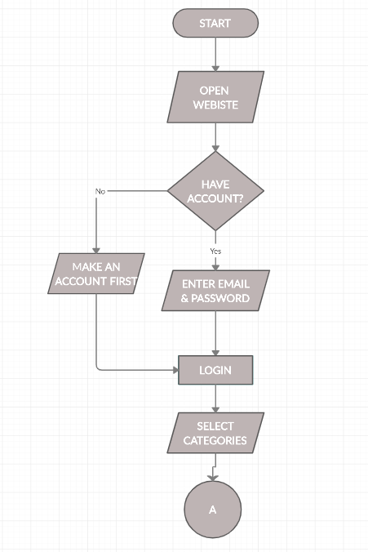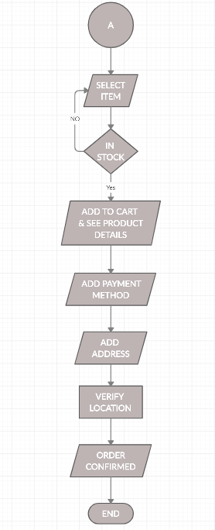 **Task No. 2: Actor Use Case Diagram  
  
Solution:** 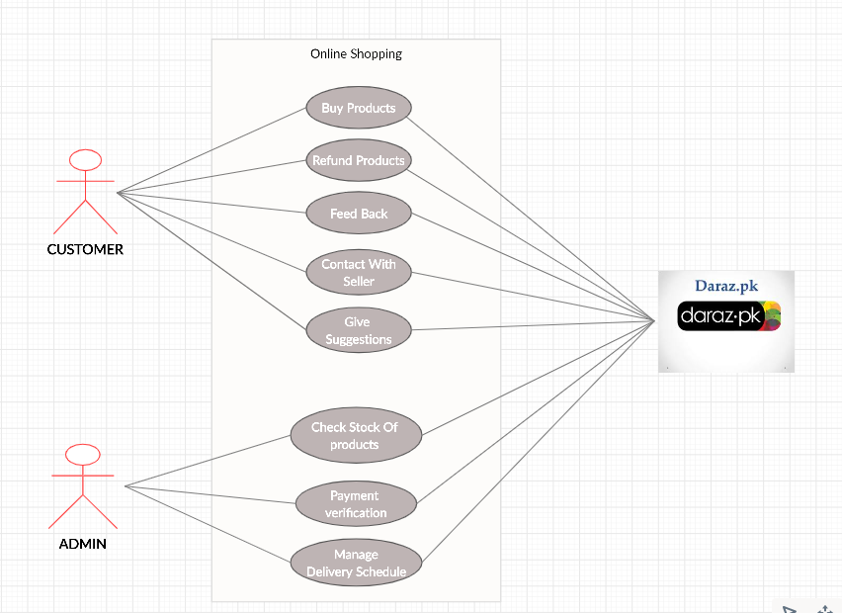

**Task No. 3: Activity Diagram**

**Solution:**

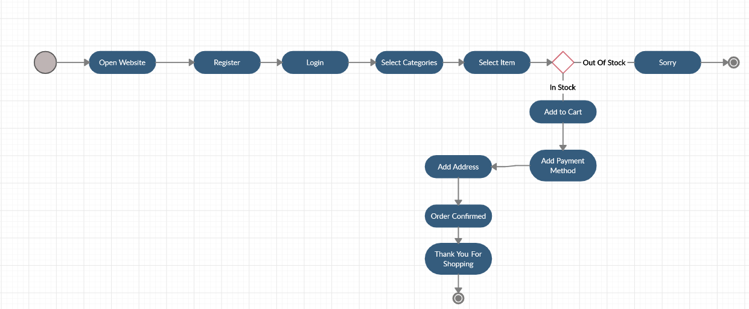

**Task No. 4: Sequence Diagram**

**Solution:** 